**Air Traffic Control Crisis? Insights into Flight Delays Caused by Air Traffic Control Staffing Shortage During the 2018-2019 Government Shutdown**

By Abby Krause

**Introduction**

The United States is experiencing a significant problem in air traffic control (ATC) staffing1. An episode of Freakonomics Radio interviewed some experts regarding how the system is broken. The air traffic control system is complicated with controllers following the flight every step of the route, starting with pushing away from the departure gate to pulling into the destination. This system relies on about 14,000 controllers managing about 45,000 flights each day1. ATC is cognitively demanding1 and highly stressful, with millions of lives riding on quick, accurate decision making. One facet of the shortage problem began in the 1980s, when President Reagan fired about 11,000 air traffic controllers and replaced them with new employees1. Now, this "class" of controllers is retiring, and the new "class" is unable to fill all those spots1. Another reason for the shortage is the training itself. It takes a high level of skill to be proficient in the career and therefore requires a significant training system and period of time1. During COVID, training was suspended and as highly evolving field, catching up on that training takes time1. The current system also makes it difficult for employees to move around to different facilities1. Each facility requires additional training for a controller to become fully competent at that facility1.

A new facet to the ATC shortage is prolonged government shutdown. Multiple news outlets from across the political spectrum have reported that ATC shortages have caused the FAA to reduce air traffic and that politicians have warned the public about flight delays and cancellations2, 3, 4 during the recent (2025) government shutdown. NPR reported that while there are not enough controllers, the safety of air travel has not been compromised5. To ensure safety, the amount of air traffic must be reduced to a manageable level for the remaining controllers5. This causes cancellations and delays due to the National Airspace Systems (NAS), a network of airspace management that includes “air navigation facilities, equipment and services; airports and landing areas; aeronautical charts, information and services; rules and regulations; procedures and technical information; and manpower and material”6.

If the shortage of controllers continues, then to ensure the safety of millions of Americans the volume of flights must be adjusted accordingly. This could cause a reduction in flights for an increasing demand, potentially raising flight prices. This study aims to confirm the media reports of increased cancellations and staffing shortage delays during a government shutdown, as a model for future staffing shortages if the issue is not resolved.

**Methods**

The U.S. Bureau of Transportation has a publicly available dataset of information regarding flights from 1987 to July of 2025. This dataset contains a record of each flight per day for a given month7. This dataset will be wrangled and analyzed to better understand flight delays, using python packages numpy, pandas, geopandas, pygris and networkx. Data from the months of November 2018, December 2018, January 2019 and February 2019 will be used for analysis.

**Results and Discussion**

November was used as baseline data and was chosen due to similar weather conditions. The airports that had the most air traffic by percentage of recorded flights are Atlanta (ATL) with 5.33%, Chicago O’Hare (ORD), Dallas Fort Worth (DFW), Denver (DEN), Charlotte (CLT), Los Angeles (LAX), Houston (IAH), San Francisco (SFO), Phoenix (PHX) and New York La Guardia (LGA).

Airports with the highest percentage of NAS delays are ALT with 7.5%, ORD, SFO, DFW, Newark (EWR), LGA, Boston (BOS), IAH, Seattle (SEA) and DEN. EWR, BOS and SEA are not in the top 10 airports by air traffic yet are in the top 10 airports by NAS delays. PHX, CLT and LAX have more traffic, yet less NAS delays. The total minutes delayed due to NAS in November 2018 are 1,768,372 and the total number of flight delays regardless of delay type is 110,741.

Figure 1

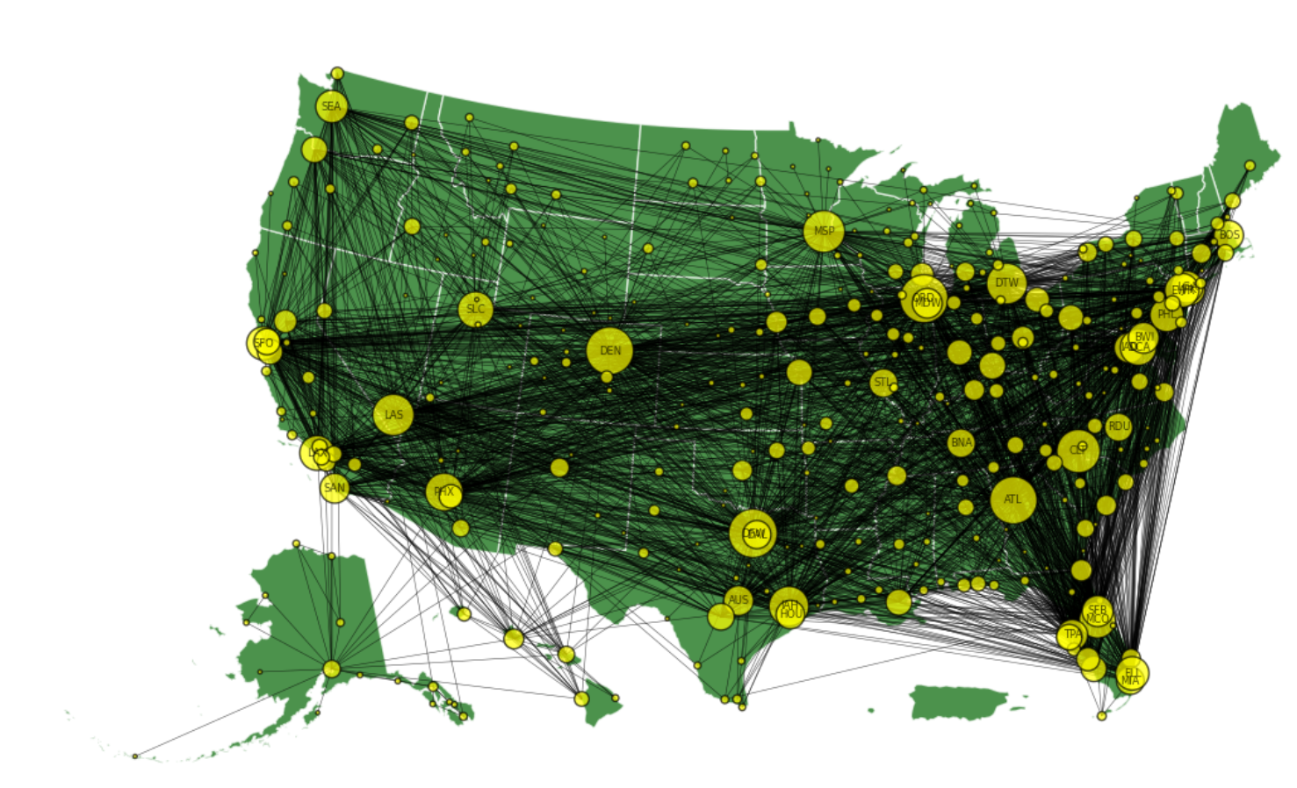

Network graph of all delayed flights in November 2018, with the airports as nodes and flight routes as edges. Node size corresponds to the number of unique flight routes associated with it. Labeled nodes are airports that are associated with at least 75 unique delayed flight routes.

Figure 1 reflects the flight routes that were delayed during the month of November 2018. The East Coast appears denser when compared to the West Coast and the northern U.S. However, this could be due to the proximity of the airports rather than more delayed flights. Still, this figure showcases the airports that have more NAS delays when compared with others. The initial assessment of DFW, ATL, CLT, DEN and ORD being top contributors to NAS delays aligns with network findings. Betweenness and degree centralities were performed on the network in figure 1. The top 5 airports with the highest betweenness centrality were DFW, DEN, ORD, ATL and Minneapolis St. Paul (MSP). These airports are on the shortest path between multiple airports indicating a potential for delay propagation. Delay propagation is recorded in the dataset as “Late Aircraft Delay” and occurs when the aircraft arrives late at one airport and arrives late at the next airport. The top 5 airports for delay propagation are ATL, ORD, DFW, DEN and LGA, indicating that MSP may not be a true propagator airport. The top 5 airports with the most delayed flights as measured by degree centrality are DFW, ORD, DEN, ATL and CLT which line up with the network in figure 1.

Figure 2

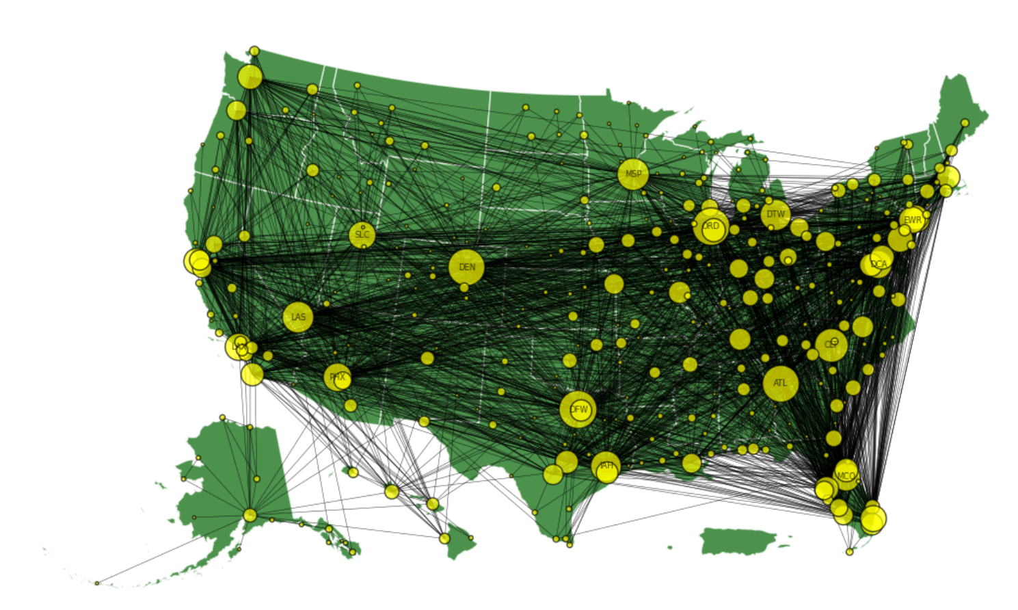

Network graph of NAS delayed flights in November 2018, with the airports as nodes and flight routes as edges. Node size corresponds to the number of unique flight routes associated with it. Labeled nodes are airports that are associated with at least 75 unique delayed flight routes.

Figure 2 reflects the flight routes of the NAS delayed flights for November in 2018. Most of the labeled nodes in figure 1 are now unlabeled, as the number of delayed flights has been reduced. Still, the larger nodes such as DFW, ATL, CLT and ORD are still labeled and show areas of edge denseness surrounding them. Betweenness and degree centralities were performed on the network in figure 2. The top 5 airports with the highest betweenness centrality were DFW, DEN, ORD, ATL and MSP. The top 5 airports with the most delayed flights as measured by degree centrality are DFW, ORD, DEN, ATL and CLT. As the NAS data is a subset of the larger dataset, similar trends in centrality is to be expected. The percentage of NAS delayed flights out of the total number of flights for November was calculated at 11.06%

During the shutdown, there were 662848 flights. Of those flights 12597 were cancelled. The airports with the highest flight volume during the shutdown were ATL with 5.2992% of all flight volume followed by ORD, DFW, CLT, DEN, LAX, PHX, IAH, SFO and Las Vegas (LAS). The top airports with the most NAS delays were ORD with 6.5256%, LGA, DFW, ATL, SFO, EWR, LAX, DEN, BOS, and IAH. Despite having a higher percentage of air traffic, LAS, CLT, and PHX are not in the top 10 percentages for NAS delays. In November, LAX was not in the top 10 percentages for NAS delays, however during the shutdown this changed. LAX therefore may have been affected more by the government shutdown when compared with the rest of the airports. The total minutes delayed due to NAS during the shutdown was 2,041,845

Figure 3

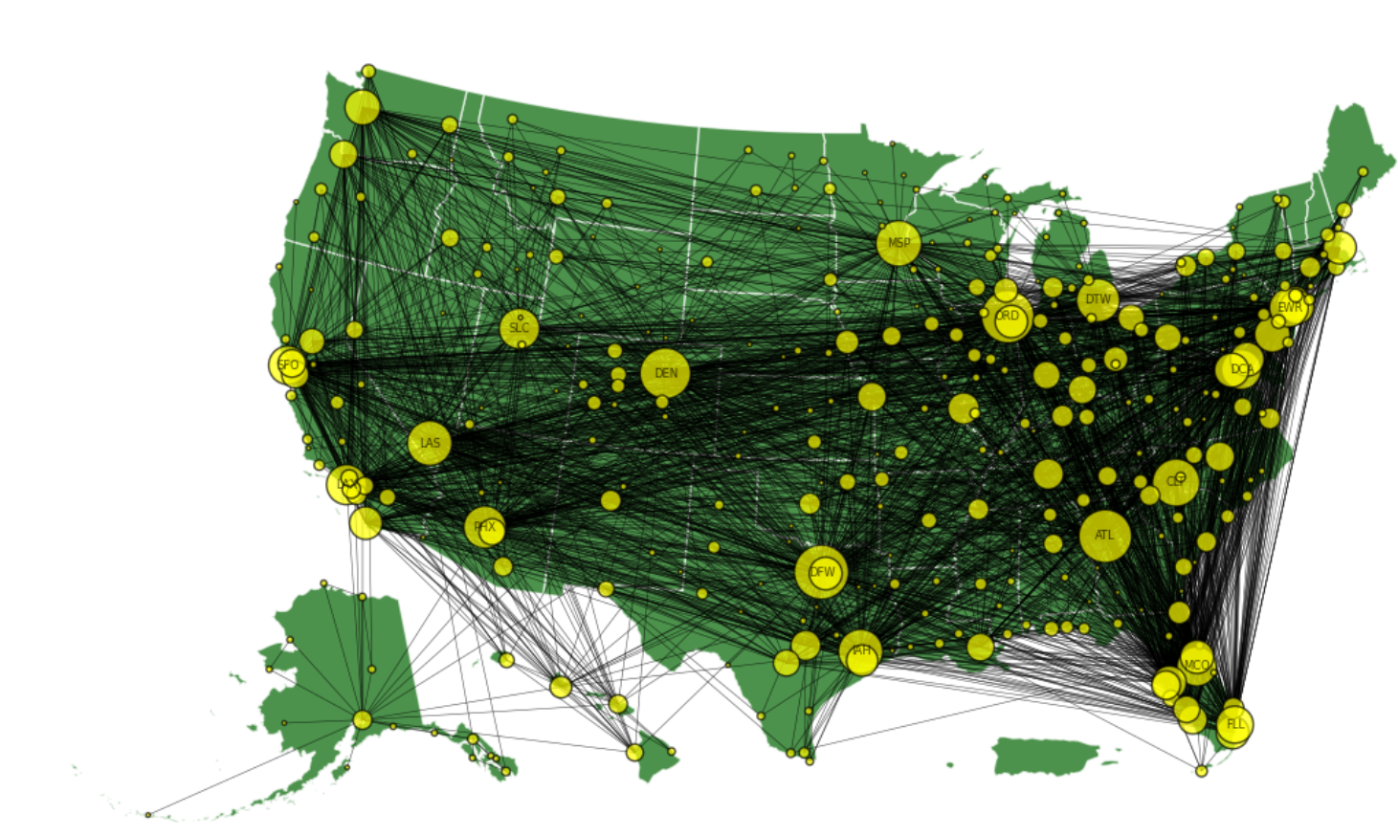

Network graph of all delayed flights during the 2018-2019 shutdown, with the airports as nodes and flight routes as edges. Node size corresponds to the number of unique flight routes associated with it. Labeled nodes are airports that are associated with at least 75 unique delayed flight routes.

Figure 3 reflects the flight routes of the flights delayed during the government shutdown. Interestingly, less nodes are labeled when compared with the November data. This indicates that less airports have at least 75 unique delayed flight routes. This could be due to the number of routes being decreased or less common routes not being as delayed. Betweenness and degree centralities were performed on the network in figure 3. The top 5 airports with the highest betweenness centrality were DFW, ORD, DEN, ATL and MSP. The top 5 airports with the most delayed flights as measured by degree were DFW, ATL, ORD, DEN and CLT.

Figure 4

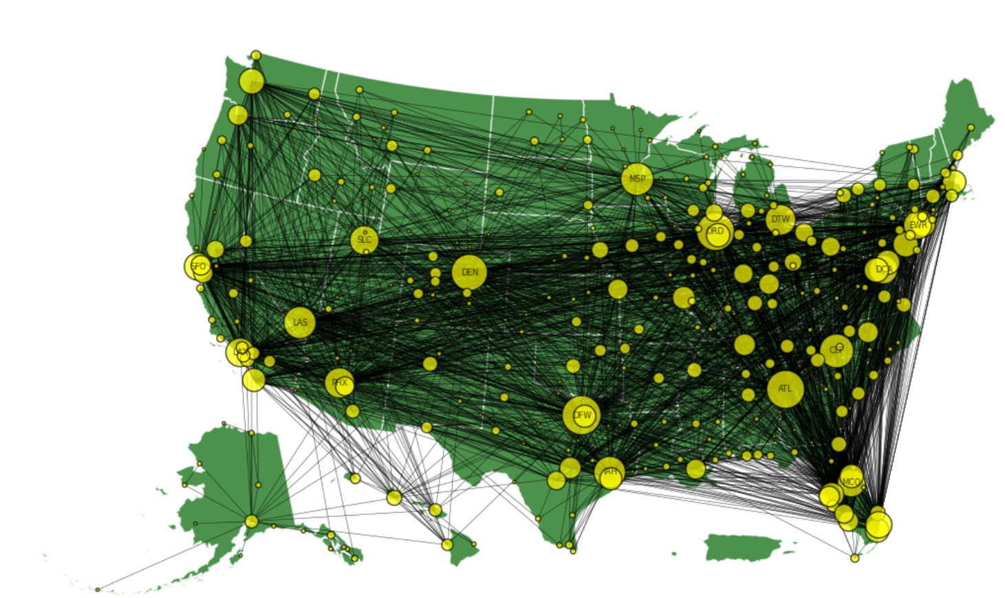

Network graph of NAS delayed flights during the 2018-2019 shutdown, with the airports as nodes and flight routes as edges. Node size corresponds to the number of unique flight routes associated with it. Labeled nodes are airports that are associated with at least 75 unique delayed flight routes.

Figure 4 reflects the flight routes of the NAS delayed flights during the 2018-2019 shutdown. Only a few nodes are still labeled representing the decrease in airports with over 75 unique flight routes delayed due to NAS. Still, the larger nodes such as DFW, ATL, CLT and ORD are still labeled and show areas of edge denseness surrounding them. Betweenness and degree centralities were performed on the network in figure 4. The top 5 airports with the highest betweenness centrality were DFW, ORD, DEN, ATL and MSP. The top 5 airports with the most delayed flights as measured by degree centrality are DFW, ATL, ORD, DEN and CLT. Once again, as the NAS data is a subset of the larger dataset, similar trends in centrality is to be expected. The percentage of NAS delayed flights out of the total number of flights for November was calculated at 10.66%

The spearman correlation was calculated at 0.9426324947027757 Indicating the graphs are structurally very similar. This is to be expected as the mapping of the airports and the routes of the flights are not changing and this is confirmed with a p-value of 2.7051351686489327e-159 indicating the similarity is not due to random chance. Given the percentages of the NAS delays differed by only 0.4%, it seems the shutdown did not have an impact on the number of routes affected by NAS delays.

Figure 5

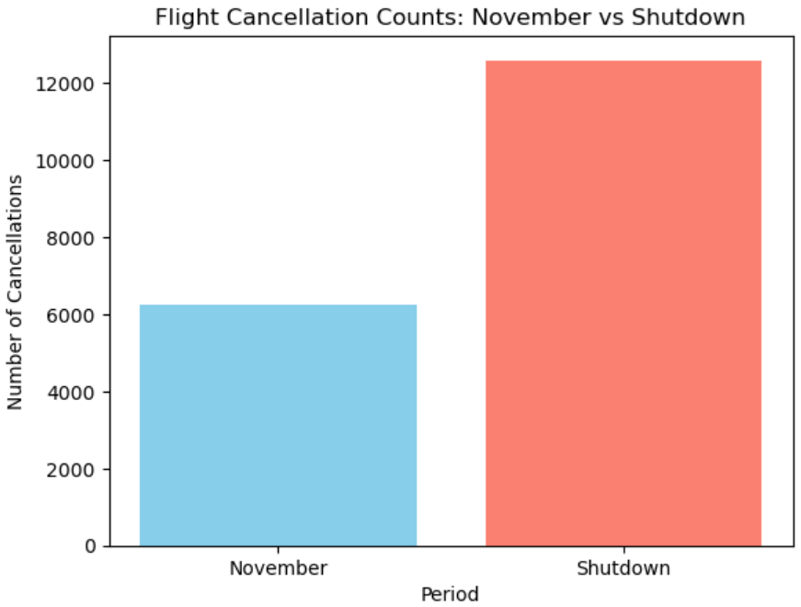

Histogram of the number of flights cancelled in November and during the shutdown. During the shutdown, 12597 flights were cancelled and in November 6254 flights were cancelled.

About 1% of flights were cancelled in November, while about 2% were cancelled during the shutdown.

ATC is not the only aspect of the aviation industry that has experienced staffing shortages, especially during government shutdowns. The Transportation Security Administration (TSA) also experienced shortages in their staffing8, 9. Exploration into data relating to security would provide deeper insight into the aviation industry during the 2018-2019 government shutdown. The data for the 2025 government shutdown is not currently available, but a comparison of the previous shutdown and the current shutdown could provide additional useful insights. Further expansion of data surrounding the shutdowns could provide interesting conclusions on the recovery of the aviation industry following a government shutdown. Increasing the resilience of the systems in place and the recovery timeframe following a shutdown could prove to essential to the industry if these shutdowns become more frequent.

Sources

1. <https://freakonomics.com/podcast/is-the-air-traffic-control-system-broken/>
2. [Government shutdown hits air travel, closing Burbank control tower and causing delays across the country | CNN](https://www.cnn.com/2025/10/07/us/government-shutdown-air-travel-hnk)
3. [Government shutdown disrupts flights, air traffic control : NPR](https://www.npr.org/2025/10/07/nx-s1-5564638/flight-delays-government-shutdown-air-traffic-control)
4. [Government shutdown exacerbates controller crisis | Fox Business](https://www.foxbusiness.com/lifestyle/retired-air-traffic-controller-warns-shutdowns-toll-us-skies-you-cant-mail-in)
5. [Air traffic controllers may play role in ending government shutdowns : NPR](https://www.npr.org/2025/10/02/nx-s1-5560219/air-traffic-controllers-ending-government-shutdown)
6. [National Airspace System | Federal Aviation Administration](https://www.faa.gov/air_traffic/nas)
7. <https://www.transtats.bts.gov/DL_SelectFields.aspx?gnoyr_VQ=FGJ&QO_fu146_anzr=b0-gvzr>
8. [How could a government shutdown affect travel around the U.S.? - CBS News](https://www.cbsnews.com/news/government-shutdown-2025-travel-tsa-faa/)
9. [Is it safe to fly during the government shutdown? Here’s what aviation experts say | CNN](https://www.cnn.com/2025/11/03/us/government-shutdown-aviation-safety)